**Lecture Note for Numerical Analysis (14) Gauss Quadrature Formula**

1. **Concept of Gauss Quadrature**

* **Gauss quadrature** implements a strategy of positioning any two points on a curve to define a straight line that would balance the positive and negative errors.
* Hence the area evaluated under this straight line provides an improved estimate of the integral.

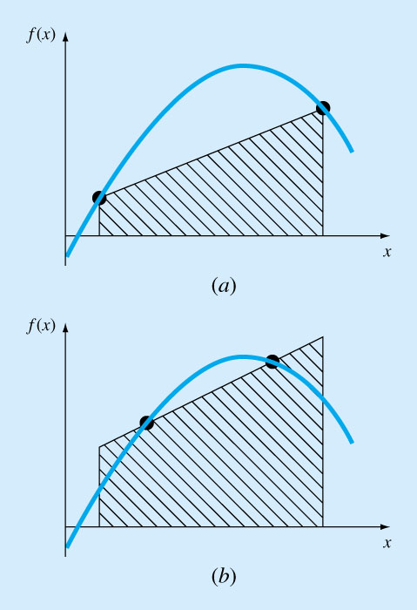

1. **Standard Form of Integration for Gauss Quadrature Application**

* **Gauss quadrature** can be standardized by using the integration interval of



to calculate



* **Affine Transformation**

🡪

Using Affine transformation we can redefine above integration as



1. **Derivation of Gauss Quadrature Formula**

* **If we use the standard form, the integration can be estimated by integrating the following form**



* **General form of n-point Gauss Quadrature Formula**



where

: Gauss Quadrature points

: Gauss Quadrature weights

should be determined to balance the positive and negative errors

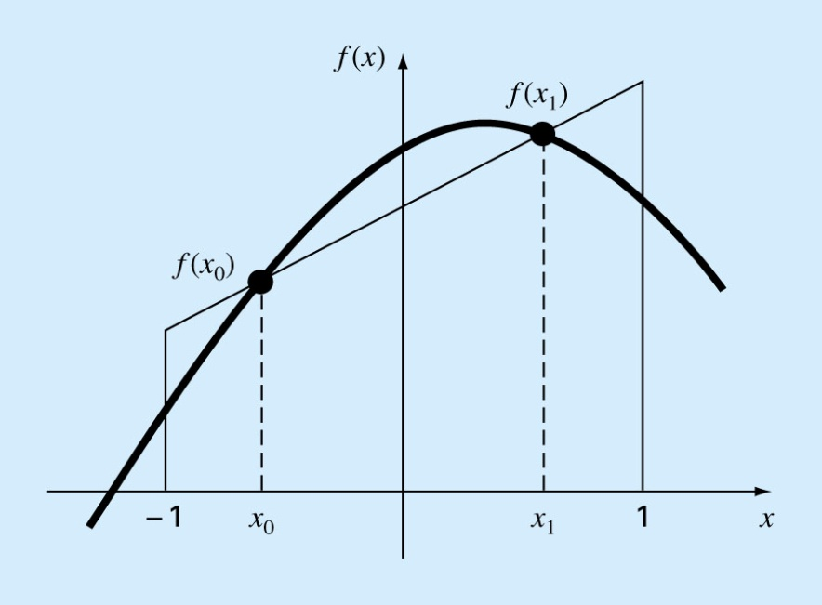

(3-1) Two-point Gauss quadrature formula to exactly integrate  with 



🡪

From the 2nd and 4th equations,

🡪

From the 2nd equation,

 since 

From the 1st equation,



From the 3rd equation



Therefore the integration formula becomes



(3-2) Performance of two-point Gauss quadrature formula

(a) 2nd order polynomial function: 

- Exact integration of 



- Gauss Quadrature formula results in the same value



(b) 3rd order polynomial function: 

- Exact integration: 

- Gauss Quadrature formula results in the same value



(c) 4th order polynomial function: 

- Exact integration: 

- Gauss Quadrature formula generates some error



**In general, the n-point Gauss Quadrature formula gives the exact integration up to (2n-1)th order polynomials**

1. **Application of Gauss Quadrature Formula**

* **Given**

- Number of Gauss Quadrature Point: 

- Data for Gauss Quadrature Point

(a) Arguments : 

(b) Weights : 

- Function and the integration interval



* **Transform using the affine transformation to get the standard form**



* **Integration Formula**



* **Weights and function arguments x in Gauss Quadrature for the different number of quadrature points**

|  |  |  |
| --- | --- | --- |
| Points *n* | Weighting Factors | Function Arguments |
| 2  3  4  5  6 |  |  |

**Example 1]**

* **Given for n=3**

|  |  |  |
| --- | --- | --- |
| Points *n* | Weighting Factors | Function Arguments |
| 3 |  |  |

 🡪 Exact Integral 

* **Solution**





1. **Pseudo code for the Gauss Quadrature**

**Program main**

% Input

n =3;

xmin = 0.0;

xmax = 5.0;

dx_plus = 0.5*(xmax+xmin);

dx_minus = 0.5*(xmax-xmin);

% Guass quadrature nodes and weights

**call** gauss_node(n,tau,w);

% Integration using Guass quadrature formula

gauss_integral = 0.0;

do j=1, n

x = dx_minus*tau(j)+dx_plus;

**call** f(x,y);

gauss_integral = gauss_integral + w(j)*y;

end do;

gauss_integral = dx_minus*guass_integral;

**end program main**

**function gauss_node(n,tau,w)**

if n=2, then

,

, 

else if n=3, then

,,

,,

else if n=4, then

,,,

,,,

else

print*,‘node number n exceeds the maximum allowed node number= 4.’

print*, ‘Please add the node information (Gauss quadrature points and weights’

stop

end if

**end function gauss_node**

**function f(x,y);% Function to be integrated, which should be specified by the user**

**y=3.0*x*x*x+2.0*x;**

**end function f**

1. **Advanced Topics on Gauss Quadrature**

**(6-1) Theorem (Gauss quadrature)** Let  be the set of the zeros of the polynomial  orthogonal with respect to a weighting function . Then there exists a unique set of quadrature weights defined by



and the exact weighted integration of the polynomial function , the degree of which is less than or equal to

2N+1, can be obtained with



The quadrature weights are all positive and expressed as



Where  and  are the leading coefficients and , respectively. And

is the weighted function norm of .

**(6-2) Othogonal Polynomial example: Legendre polynomials orthogonal w.r.t** 

**Important Characteristics of the Legendre polynomials**

* + Legendre polynomials: Eigen functions of the sigular Sturm-Lioville problem

 with 

* + Leading coefficient of N-th order Legendre polynomial

 in 

* + Orthogonality with unit weighting function



* + Three term recurrence formula



* + Recurrence relation for derivatives



**Derivation of Legendre polynomials using the recurrence relation**







**(6-3) Gauss Quadrature nodes**  **and weights** 

**Nodes are zeros of** 



, the roots of which are generally calculated using the numerical root finding method.

**Weights:** 

Using the following relations





🡪

The quadrature weights can be written as (also, weights are generally calculated using numerical methods)



**Gauss Quadrature Nodes and Weights**



|  |  |  |  |  |
| --- | --- | --- | --- | --- |
| N | No Node weight |  | N | No Node weight |
| 1 | 1 0.000000000000E+00 .200000000000E+01 |  | 2 | 1 -.577350269190E+00 .100000000000E+01  2 0.577350269190E+00 .100000000000E+01 |
| 3 | 1 -.774596669241E+00 0.555555555556E+00  2 0.000000000000E+00 0.888888888889E+00  3 0.774596669241E+00 0.555555555556E+00 |  | 4 | 1 -.861136311594E+00 .347854845137E+00  2 -.339981043585E+00 .652145154863E+00  3 0.339981043585E+00 .652145154863E+00  4 0.861136311594E+00 .347854845137E+00 |
| 5 | 1 -.906179845939E+00 0.236926885056E+00  2 -.538469310106E+00 0.478628670499E+00  3 0.000000000000E+00 0.568888888889E+00  4 0.538469310106E+00 0.478628670499E+00  5 0.906179845939E+00 0.236926885056E+00 |  | 6 | 1 -.932469514203E+00 0.171324492379E+00  2 -.661209386466E+00 0.360761573048E+00  3 -.238619186083E+00 0.467913934573E+00  4 0.238619186083E+00 0.467913934573E+00  5 0.661209386466E+00 0.360761573048E+00  6 0.932469514203E+00 0.171324492379E+00 |
| 7 | 1 -.949107912343E+00 0.129484966169E+00  2 -.741531185599E+00 0.279705391489E+00  3 -.405845151377E+00 0.381830050505E+00  4 0.000000000000E+00 0.417959183673E+00  5 0.405845151377E+00 0.381830050505E+00  6 0.741531185599E+00 0.279705391489E+00  7 0.949107912343E+00 0.129484966169E+00 |  | 8 | 1 -.960289856498E+00 0.101228536290E+00  2 -.796666477414E+00 0.222381034453E+00  3 -.525532409916E+00 0.313706645878E+00  4 -.183434642496E+00 0.362683783378E+00  5 0.183434642496E+00 0.362683783378E+00  6 0.525532409916E+00 0.313706645878E+00  7 0.796666477414E+00 0.222381034453E+00  8 0.960289856498E+00 0.101228536290E+00 |
| 9 | 1 -.968160239508E+00 0.812743883616E-01  2 -.836031107327E+00 0.180648160695E+00  3 -.613371432701E+00 0.260610696403E+00  4 -.324253423404E+00 0.312347077040E+00  5 0.000000000000E+00 0.330239355001E+00  6 0.324253423404E+00 0.312347077040E+00  7 0.613371432701E+00 0.260610696403E+00  8 0.836031107327E+00 0.180648160695E+00  9 0.968160239508E+00 0.812743883616E-01 |  | 10 | 1 -.973906528517E+00 0.666713443087E-01  2 -.865063366689E+00 0.149451349151E+00  3 -.679409568299E+00 0.219086362516E+00  4 -.433395394129E+00 0.269266719310E+00  5 -.148874338982E+00 0.295524224715E+00  6 0.148874338982E+00 0.295524224715E+00  7 0.433395394129E+00 0.269266719310E+00  8 0.679409568299E+00 0.219086362516E+00  9 0.865063366689E+00 0.149451349151E+00  10 0.973906528517E+00 0.666713443087E-01 |
| 11 | 1 -.978228658146E+00 0.556685671162E-01  2 -.887062599768E+00 0.125580369465E+00  3 -.730152005574E+00 0.186290210928E+00  4 -.519096129207E+00 0.233193764592E+00  5 -.269543155952E+00 0.262804544510E+00  6 0.000000000000E+00 0.272925086778E+00  7 0.269543155952E+00 0.262804544510E+00  8 0.519096129207E+00 0.233193764592E+00  9 0.730152005574E+00 0.186290210928E+00  10 0.887062599768E+00 0.125580369465E+00  11 0.978228658146E+00 0.556685671162E-01 |  | 12 | 1 -.981560634247E+00 0.471753363865E-01  2 -.904117256370E+00 0.106939325995E+00  3 -.769902674194E+00 0.160078328543E+00  4 -.587317954287E+00 0.203167426723E+00  5 -.367831498998E+00 0.233492536538E+00  6 -.125233408511E+00 0.249147045813E+00  7 0.125233408511E+00 0.249147045813E+00  8 0.367831498998E+00 0.233492536538E+00  9 0.587317954287E+00 0.203167426723E+00  10 0.769902674194E+00 0.160078328543E+00  11 0.904117256370E+00 0.106939325995E+00  12 0.981560634247E+00 0.471753363865E-01 |